New Life Series

LESSON 1



SALVATION: A NEW LIFE

“For God loved the world so much that he gave his only son so that anyone who believes in him shall not perish but have eternal life”

John 3:16 (LB)

WELCOME TO NEW ERA UNIVERSITY NEW LIFE SERIES

A SPIRITUAL FOUNDATION

This lesson is designed to help you better understand Salvation, the Assurance of Salvation and the Ordinances. We view this lesson as essential in helping you lay a strong spiritual foundation upon which to develop your spiritual lifestyle. This lesson will cover three important areas:

Salvation

Assurance and Essentials of Salvation

The Ordinances



“…You are a member of God’s very own family…and you belong in God’s household with every other Christian.” Ephesians 2:19 (LB)

We are glad YOU are here!

SALVATION

“Everyone who calls on the name of the Lord will be saved.” Romans 10:13(NIV)

- Does It Matter If I Am Saved?

  - The decision to accept Jesus as your personal savior is the most important decision you will ever make in your entire life. It is more important than
    - the college you will attend
    - the career you will choose
    - who you will marry
    - where you will live, how many kids you will have, where you will work, where you will retire, etc.

- This is the only decision which has eternal ramification for you. Your decision to accept Jesus as your personal savior determines whether you will live eternally in heaven or eternally in hell.

- When you accept Jesus as your savior, you are saved from the penalty of sin which is eternal death or eternal separation from God. “The wages of sin is death, BUT the gift of God is eternal life through Jesus Christ our Lord.” Romans 6:23 (NIV)

- Your acceptance of Jesus as your savior assures that you will live eternally with God.

- What Is Salvation And Why Do I Need To Be Saved?

- The word salvation means to be preserved or delivered from eternal destruction. It means to be bought back, to be rescued from danger.

- Mankind needs salvation because mankind is sinful. “For all have sinned, and come short of the glory of God.” Romans 3:23 (KJV)

- Sin is anything which is contrary to or against God’s will. The punishment for sin is death or eternal separation from God. All mankind is guilty of sin and destined for eternal hell. “All of us, like sheep, have gone astray, and each of us has turned his own way.” Isaiah 53:6 (RSV)

- How Did Mankind Get Into This Terrible State?

What we believe about man
Mankind is made in the spiritual image of God. Man alone of all God’s creation has the ability to think and reason. Mankind is the supreme object of God’s creation. Although every person has tremendous potential for good, all of us are marred by a condition called sin that separates us from God. Mankind is free to make his own choice to serve God or to reject God. Genesis 1:27; Psalm 8:3-6; Isaiah 53:6a; Romans 3:23; Isaiah 59:1-2

- In the beginning God created the heavens and the earth, the universe, animal life, plant life and human life. Man was made in God’s image and for God’s glory (Genesis Ch.1).


“…whom I created for my glory, whom I formed and made.” Isaiah 43:7b (RSV)

- The first man and woman were Adam and Eve. God created them and placed them in the beautiful Garden of Eden to care for it. Adam and Eve had only one restriction, they were not to eat from the tree of knowledge of good and evil, to do so would bring immediate death. “But of the tree of the knowledge of good and evil you shall not eat, for in the day that you eat of it you shall die.” Genesis 2:17 (RSV)

What We Believe about GOD
God is the Creator and Ruler of the universe. He has eternally existed in three personalities, the Father, the Son and the Holy Spirit. These three are co-equal yet are one God. Genesis 1:1, 26, 27; Genesis 3:22; Psalm 90:2; Matthew 28:19; 1 Peter 1:2; 2 Corinthians 13:14

- The devil, disguised as a serpent, tempted Eve to act in self will instead of God’s will. Eve ate the forbidden fruit and gave some to her husband, Adam, who also ate. When Adam ate the fruit, he sinned. Adam’s sin caused him to die spiritually, he was separated from God. Adam also began to die physically. Adam’s sin made salvation necessary. Genesis Ch. 3

- You might be thinking Adam and Eve sinned, not me. Why do I need salvation? The Bible teaches that all have sinned and fall short of the glory of God. “For all have sinned, and come short of the glory of God.” Romans 3:23 (KJV)

- Adam is our spiritual father. He is the head of the human race. We were in his seminal seed, when he sinned, we sinned. “When Adam sinned, sin entered the entire human race. His sin spread death throughout the world…” Romans 5:12a (LB)

- Thus, we are born with a sinful nature. “But I was born a sinner, yes, from the moment my mother conceived me.” Psalm 51:5 (LB)

- Also, we sin on our own because of what we do or fail to do. “…No one is good, no one in all the world is innocent. No one has ever really followed God’s path, or even truly wanted to.” Romans 3:10-11 (LB)

- Man is sinful, BUT God is Holy. God hates sin! God must punish sin. The penalty for sin is death, physical and spiritual death, separation from God. The only way to avoid spiritual death is to accept Jesus as savior. Jesus died on the cross for our sins so we wouldn’t have to. “The wages of sin is death, BUT the gift of God is eternal life through Jesus Christ our Lord.” Romans 6:23 (NIV)

- Who Can Be Saved?

  - The Bible teaches that all can be saved. “For everyone who calls on the name of the Lord will be saved.” Romans 10:13 (NIV)

  - It is God’s desire that no man be lost.

“But God showed His great love for us by sending Christ to die for us while we were still sinners.” Romans 5:8 (LB)

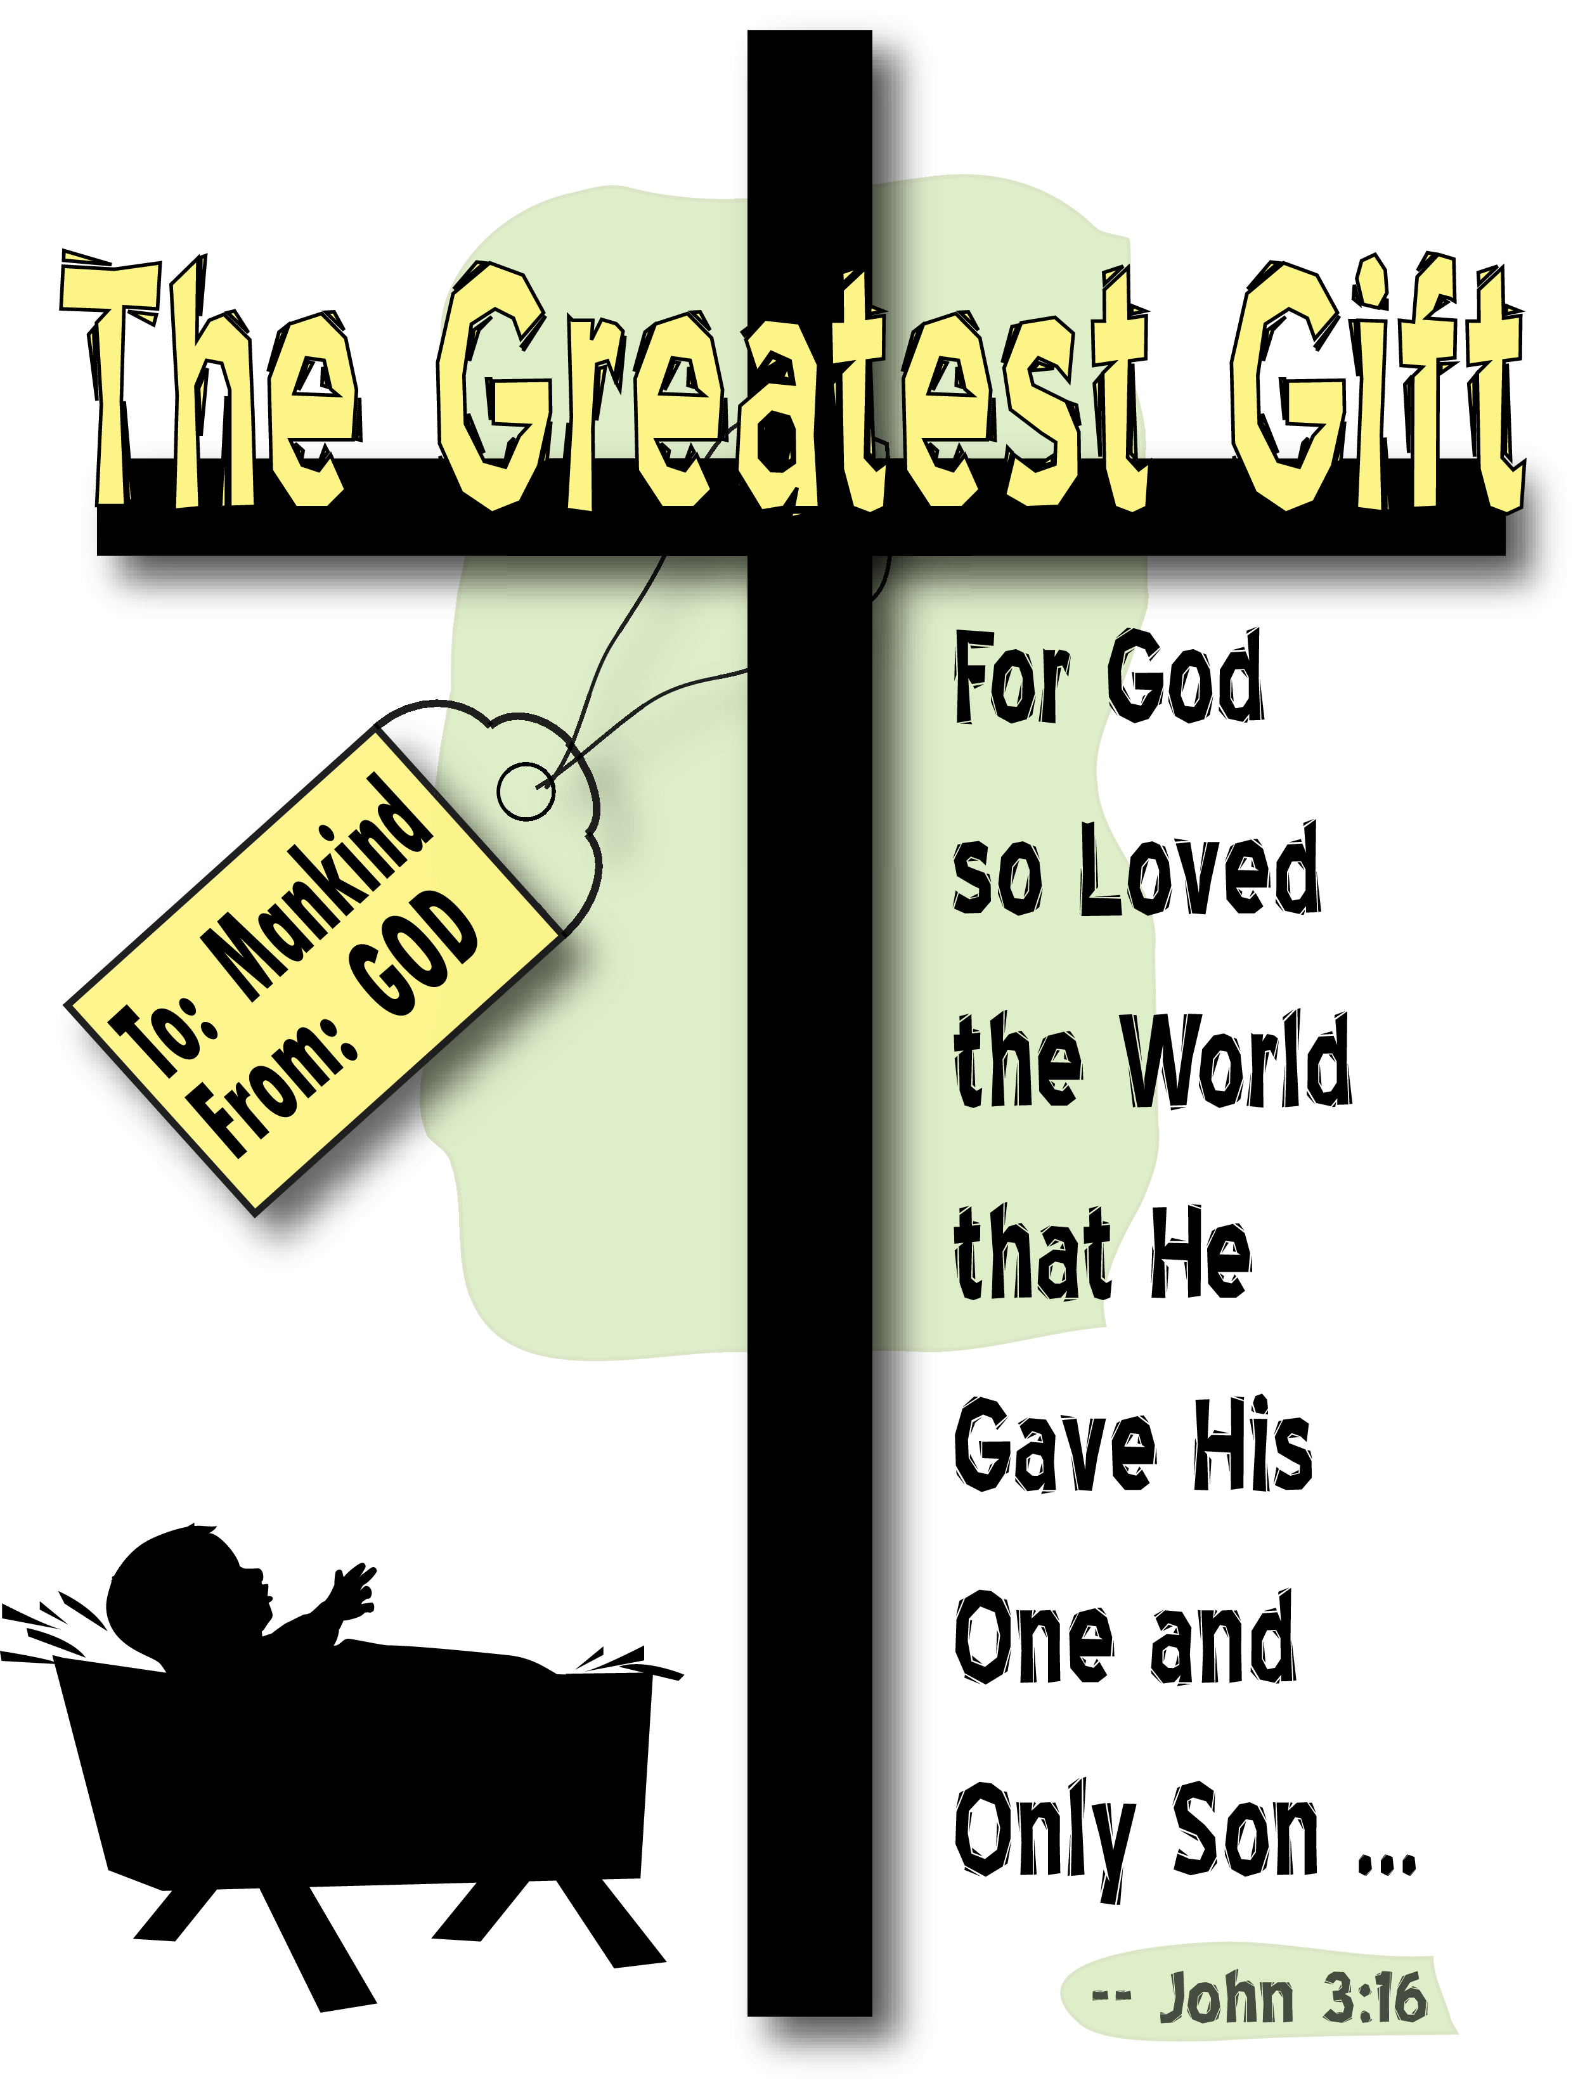
“For God loved the world so much that he gave his only Son so that anyone who believes in Him shall not perish but have eternal life” John 3:16 (LB)

  - Anyone who is willing to accept Jesus as their personal savior can be saved. It does not matter what we have done, it does not matter what we have not done. God will save us if we are willing to accept him. It is never too late if we accept him before we die.

“To all who receive Him, He gives the right to become children of God. All we need to do is to trust Him to save us. All those who believe this are reborn! This is not a physical rebirth…but from the will of God!” John 1:12-13 (LB)

What we believe about Jesus Christ
Jesus Christ is the Son of God. He is co-equal with the Father. Jesus lived a sinless human life and offered Himself as the perfect sacrifice for the sins of all people by dying on the cross. He arose from the dead after three days to demonstrate His power over sin and death. He ascended to Heaven’s glory and will return again someday to judge the people of the earth and to lead his followers to Heaven. Matthew 1:22, 23; Isaiah 9:6; John 1:1-5; Hebrews 4:14-15; 1 Corinthians 15:3-4; Romans 1:3-4; Acts 1:9-11; 1 Timothy 6:14-15; Titus 2:13

- God’s Plan

- Mankind sinned and was destined for eternal hell. Because God is Holy and because God hates sin, our sin had to be punished. No man was worthy or able to save mankind because all men are guilty of sin. So God sent His son Jesus, who came to earth as a baby with the sole purpose of dying in our place for our sin. Jesus grew up, just like you and I, but unlike you and I, he did not sin; therefore he was worthy to save mankind.

“But He [God] paid for you with the precious lifeblood of Christ,…God chose Him for this purpose long before the world began…” 1 Peter1:19-20 (LB)

- Why did Jesus have to die?

“…the law requires that…everything be cleansed with blood, and without the shedding of blood there is no forgiveness [of sin].” Hebrews 9:22 (NIV)

- When Adam and Eve sinned by eating the forbidden fruit in the Garden of Eden, God killed innocent animals and clothed Adam and Eve with the animal skins. The animals were a substitute, innocent victims dying in the place of those who deserved to die, Adam and Eve. Genesis 3:21
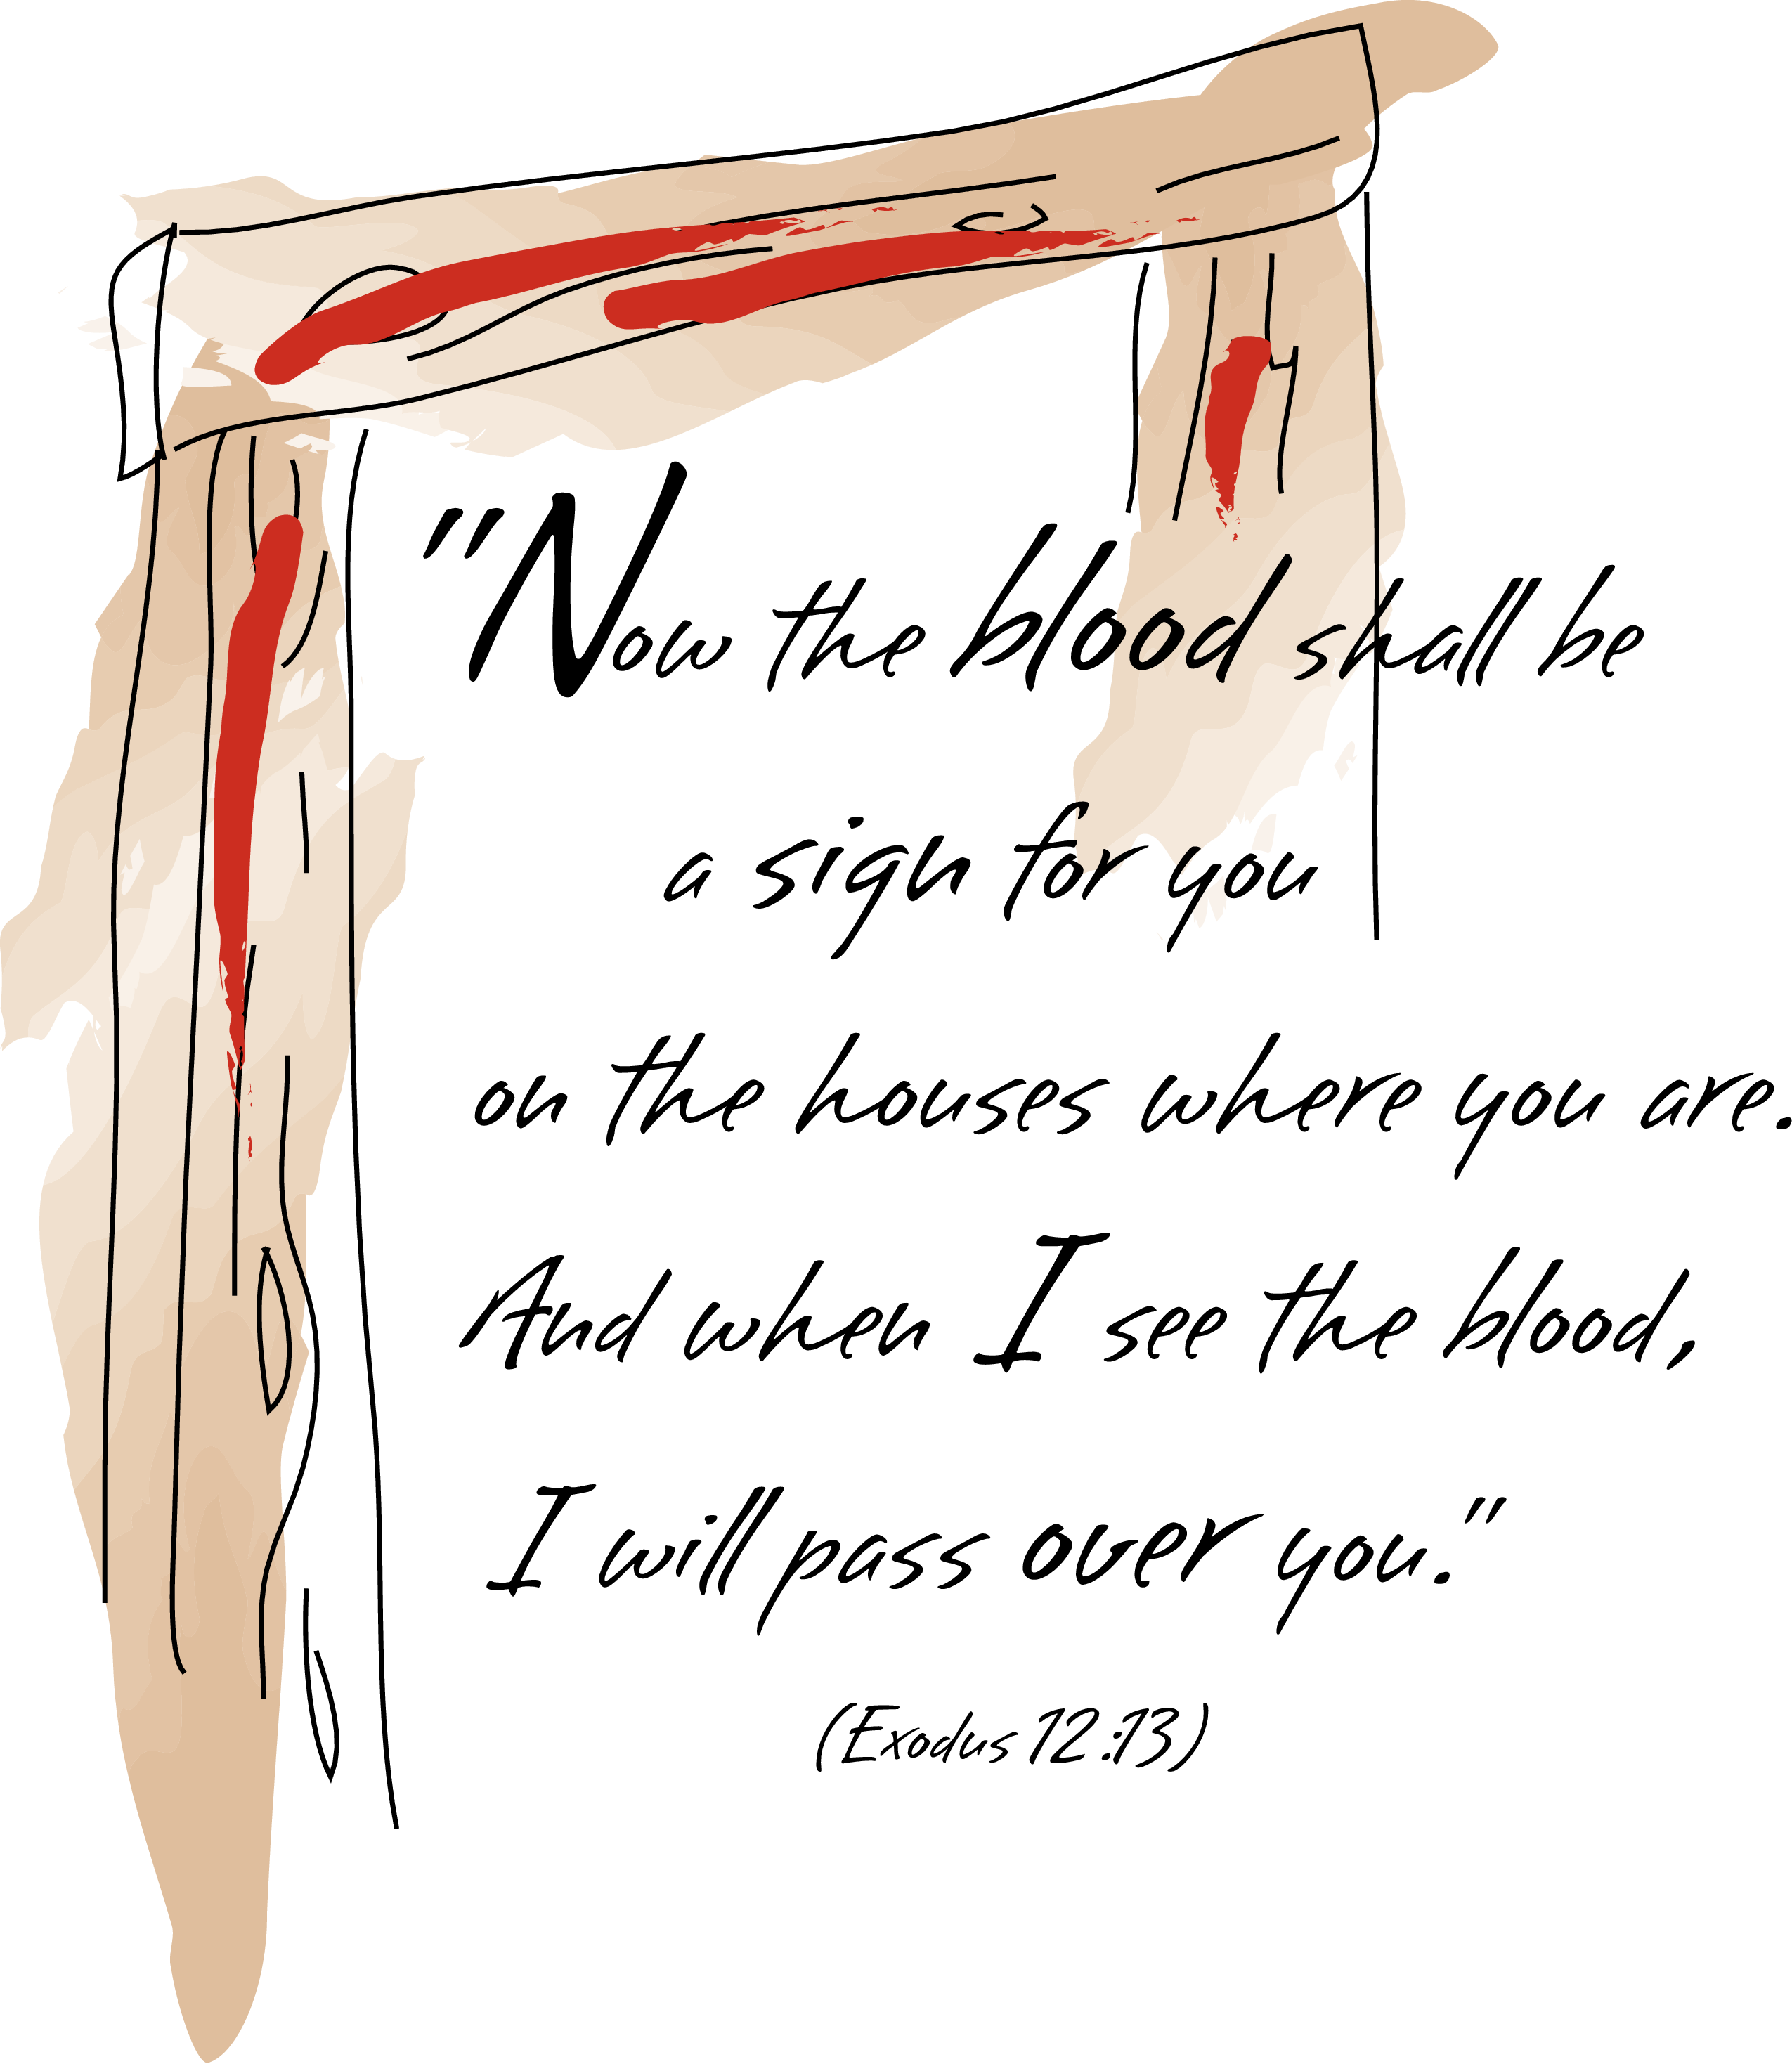
- During the Passover, when the Israelites were being led out of Egypt, a lamb was sacrificed for each Jewish family and the lamb’s blood was spread upon the doorposts so that those persons who were inside that house lives would be spared.

- Once a year on The Day of Atonement, the High Priest was allowed to enter the most holy place of the temple and offer a sacrifice for the Nation of Israel’s sins. A goat was sacrificed, and the goat’s blood was poured onto the Mercy Seat, the lid of the Ark of the Covenant (a small chest which held the Ten Commandments and symbolized the dwelling of God’s presence). Thus when God looked down on the Laws, He saw not the laws which had been broken by the people, but the blood of the innocent goat which covered the broken laws. God saw that atonement (payment) had been made and God forgave the people’s sins. The goat was a substitute; an innocent victim dying in the place of those who deserved death (the Nation of Israel).

- Jesus became our sacrificial lamb; he died on the cross for our sins so we can have eternal life. He was our substitute.

John the Baptist pointed to Jesus and said “Look, the Lamb of God, who takes away the sin of the world! John 1:29 (NIV)

- The sacrifices of the Old Testament system had to be repeated again and again, year after year. When Jesus came to earth, he sacrificed himself once, thereby accomplishing forever all that needed to be accomplished. We need only to believe in Jesus’ atoning work if we are to be saved. There is no other condition for salvation. “Christ was sacrificed once to take away the sins of many people.” Hebrews 9:28 (NIV)

- Why was Jesus the only person worthy to die for mankind’s sins?

(a) Unlike every other person, Jesus was born without sin. That is because unlike you and I, whose Father was Adam, Jesus’ father was God Himself. Thus Jesus was born without a sinful nature. “And the angel answered and said unto her, the Holy Ghost shall come upon thee and the power of the Highest shall overshadow thee: therefore also that holy thing which shall be born of thee shall be called the son of God.” Luke 1:35KJV

(b) Also, unlike you and I who sin when we are tempted, Jesus was the only person tempted who did not yield to sin. “… [Jesus] but was in all points tempted like as we are, yet without sin.” Hebrews 4:15KJV

(c) God required a perfect sacrifice to atone (make payment) for mankind’s sin. Jesus was the only person who met God’s requirements because he himself is 100% God to 100% man. Thus, Jesus died for our sins. “How much more, then, will the blood of Christ, who through the eternal Spirit offered himself unblemished to God, cleanse our consciences from acts that lead to death, so that we may serve the living God!” Hebrews 9:14

- What Does Sin Look Like?

YOU GOD

SIN = DEATH =

ETERNAL SEPARATION FROM GOD

- What’s the Solution? How do we get back to God?

Jesus said, “I AM THE WAY, the truth and the life. No man comes to the Father, EXCEPT THROUGH ME!” John 14:6 (NIV)

God came to earth as a human being, [in Jesus] to bring us back to Himself. If any other way would have worked to get us back to God, Jesus wouldn’t have had to come and die.

1. Jesus is the only bridge back to the Father!
YOU GOD

JESUS
“But God showed His great love for us by sending Christ to die for us while we were still sinners.” Romans 5:8 (LB)
2. We must accept Jesus as Savior if we expect to get back to
God.

What we believe about eternity
People were created to exist forever. We will either exist eternally separated from God by sin, in Hell or eternally with God through forgiveness and salvation, in Heaven. Heaven and Hell are real places of eternal existence. John 3:16; John 12:25; John 5:11-13; Romans 6:23; Revelations 20:15

- Why Did God Send Jesus To Die In Our Place?

God did this for US, because He loves us and wants us to know Him.

“God showed His great love for us by sending Christ to die for us while we were still sinners.” Romans 5:8 (LB)

- What Does God Want Me To Do?

- ADMIT that I am a sinner.
- “Yes, all have sinned; all fall short of God’s glorious ideal.” Romans 3:23 (LB)
- “If we claim we have not sinned, we are lying and calling God a liar, for he says we have sinned.” 1 John 1:10 (LB)
- BELIEVE that Jesus died on the cross to pay for my sin and that He rose again and is alive today.
- “God showed His great love for us by sending Christ to die for us while we were still sinners.” Romans 5:8 (LB)

- REPENT ask GOD to forgive me for my sin and turn from my sin.
- “If we confess our sins, He is faithful and just and will forgive us our sins and cleanse us from every wrong.” 1 John 1:9 (LB)

- ACCEPT Jesus as my personal savior – God’s free gift of salvation.
- “For it is by grace you are saved, through faith, and this not from yourselves, it is the gift of God, not by works, so that no one can boast.” Ephesians 2:8-9 (NIV)
- ALLOW Jesus Christ to come into my life and be the “Director”/Lord of my life.

- “Jesus says, ‘Listen! I stand at the door and knock. If anyone hears my voice and opens the door, I will come in…” Revelation 3:20

If you have completed steps 1 through 5 above and meant it from your heart, you are saved!

If you are not sure you are saved, you can take these steps now by praying a simple prayer of commitment to God:

Dear Jesus,

I know that I am a sinner.
I am sorry for my sin.
Please forgive me for my sin.
I believe you died on the cross for my sin.
I believe you arose on the third day.
I believe you will come back for me one day.
I accept you as my personal savior.
Please come into my heart and help me to live for you.
Thank you for saving me.
Amen.

If you just prayed the above prayer and really meant it from your heart, YOU ARE SAVED!

X. How Can I Be Sure I Am Saved?

We can be sure that we are saved because the Word of God tells us:

“Everyone who calls on the name of the Lord will be saved.” Romans 10:13 (NIV)
So, whether you just prayed the previous prayer or you accepted Jesus at a previous time, you can be assured from Romans 10:9 that you are saved and you can answer with confidence that you will spend eternity with Jesus in heaven based upon the FACT of God’s Word.

What we believe about Salvation

Salvation is God’s free gift to us but we must accept it. We can never make up for our sin by self-improvement or good works. Only by trusting in Jesus Christ as God’s offer of forgiveness can anyone be saved from sin’s penalty. When we turn from our self-centered or sin ruled life and turn to Jesus in faith we are saved. Eternal life begins the moment one receives Jesus Christ into his life by faith. John 3:16; Romans 6:23; Ephesians 2:8, 9; John 14:6; John 1:12; Titus 3:5; Galatians 3:26; Romans 5:1

ASSURANCE AND ESSENTIALS OF SALVATION

“Everyone who calls on the name of the Lord will be saved.” Romans 10:13 (NIV)

- How Can I Be Sure I Am Saved?

- What is the assurance of salvation based upon? The assurance of salvation must rest upon the Word of God - the Christian’s ultimate authority.

- If you accept and believe the Word of God, Titus 1:2 states “God cannot lie.” Romans 10:9 states “For if you tell others with your own mouth that Jesus Christ is your Lord, and believe in your own heart that God has raised him [Jesus] from the dead, you will be saved.” (LB)

- If you have done what Romans 10:9 states, and sincerely meant it, the Word of God is emphatically clear you will be saved!

It does not say, YOU MIGHT BE, YOU MAY BE, YOU WILL BE LATER ON, but that you will be saved!

- The story of the Philippian Jailer in Acts 16:25 - 33 is a good example. In response to the jailer’s request about how to be saved: 1.) Paul preached the Gospel; 2.) The Jailer heard the Gospel; 3.) The Jailer believed the Gospel; 4.) The Jailer accepted the Gospel; 5.) The Jailer was saved!

- We Cannot Depend On Our Feelings!

It’s important to know that we cannot depend upon our feelings in this matter. Sometimes we don’t feel any different, we don’t look any different, and sometimes we don’t act any different. All we have to go on is the fact that we repented, the fact that we believed, the fact that we asked Jesus to come into our heart. This is where our belief in the Word of God comes in. The PROMISE of God’s Word, not our FEELINGS, is our authority. The Christian lives by FAITH in the TRUSTWORTHINESS of God and His Word.

- What Are The Results Or Benefits Of Salvation?
- In our study of salvation thus far, we have learned three unquestionable truths:

a) Every man by nature is a sinner; b) God through the cross has provided salvation for all who believe; c) the only two requirements to receive salvation are to repent and believe that God will save you.
2. What are the RESULTS or BENEFITS in the life of the individual who meets the requirements of salvation by repenting of his sin and placing his faith in Jesus as Lord and Savior?

- Salvation results in the individual being born into the family of God. John 3:1-18
    - God becomes his father. John 1:12-13
    - Jesus becomes his elder brother. Matthew 12:48-50
    - Believer becomes a joint-heir with Jesus in all of the riches of heaven.
Romans 8:16-17
    - The Holy Spirit becomes his guide in life, both leading him into the paths of righteousness and empowering him to walk therein. John 16:12-15

- Salvation results in the individual being a possessor now of eternal life.
John 5:24

- Salvation results in the individual becoming a new creation in Christ Jesus.
2 Corinthians 5:17

- Salvation results in the individual having his sins forgiven. Ephesians 1:7

- Salvation results in the individual being at peace with God. Romans 5:1

- Salvation results in the individual being assured that God has not only provided redemption for his soul, but for his body as well. 1Thessalonians 4:13-18; 1 Corinthians 15:51-57

- Salvation results in the believer’s justification, being put back into a right relationship with God. Romans 5:1

H. Salvation results in the believer being sealed (kept, protected) unto the day of redemption, the believer is eternally secure, unable to lose his salvation. Ephesians 4:30; Romans 8:35-39

I. Salvation results in the believer having the power over sin. Jude 24-25 (LB); Romans 8:2

- What Are The Evidences Of Salvation?

Probably the most perplexing question for most believers still remains: How can I be sure that I am saved? What are the EVIDENCES of my salvation?

- Faithfulness to Christ. 1 Corinthians 4:2; Acts 1:12; 2:4

- Willingness on the part of the believer to acknowledge the Lordship of Christ over one’s life. 1 Corinthians 12:3b (See Zacchaeus’ example) Luke 19:1-10

- A sincere desire to share one’s abundance with others. (See Zacchaeus’ example) “The half of my goods I give to the poor.” Luke 19:8
- A determination to make restitution for wrong doing. (See Zacchaeus’ example) “If I have taken anything from any man by false accusation, I will restore him fourfold.” Luke 19:8

- The witness of the Holy Spirit in the life of the believer. Romans 8:14-17; 1 John 4:13

- Love for one’s Christian brother. 1 John 3:14

- Compassion for the lost which motivates the believer to witness to others concerning his faith. John 1:40-42

- What Is God’s Purpose In Salvation?

There are TWO PURPOSES in God’s providing salvation for man.

- In the beginning God created man for the purpose of having personal fellowship with him. This relationship was based on mutual love. When sin came, that love relationship, that fellowship was broken. God provided salvation through the death of Christ that this fellowship might be restored. 1 Corinthians 1:9

- God has saved the believer to serve. Ephesians 2:8-10

- What Else Do I Need To Know About Salvation?

You might be asking, “Is there anything else really important that I need to know about Salvation?” Yes, there is!

- The act of salvation is initiated and carried out entirely by God.
Because of his kindness you have been saved through trusting Christ. And even trusting is not of yourselves; it too is the gift from God. Salvation is not a reward for the good we have done, so none of us can take any credit for it. Ephesians 2:8-9 (LB)

- The moment one accepts Christ as his/her personal savior, several things happen:

(a) immediately baptized into body of Christ “for all of you who were baptized into Christ have clothed yourselves with Christ.” Galatians 3:27 (NIV)

(b) sealed unto the day of redemption “And now you Gentiles have also heard the truth, the Good News that God saves you. And when you believed in Christ, he identified you as his own by giving you the Holy Spirit, whom he promised long ago. The Spirit of God’s guarantee that he will give us the inheritance he promised and that he has purchased us to be his own people. He did this so we would praise and glorify him. Ephesians 1:13-14 (LB)

(c) indwelt and empowered by the Holy Spirit “And I will ask the Father, and he will give you another Advocate, who will never leave you. He is the Holy Spirit, who leads into all truth. The world cannot receive him, because it isn’t looking for him and doesn’t recognize him. But you know him, because he lives with you now and later will be in you”. John 14:16-17; “And because you belong to him, the power of the life-giving spirit has freed you from the power of sin that leads to death.” Romans 8:2

What we believe about the Holy Spirit
The Holy Spirit is co-equal with the Father and the Son of God. He is present in the world to make men aware of their need for Jesus Christ. He is the essential part of living the Christian life and is received by faith into the life of a believer. He provides the Christian with power for living, understanding of spiritual truth, and guidance in doing what is right. He gives every believer a spiritual gift to use in serving God’s Kingdom. As Christians we seek to live under his control daily. 2 Corinthians 3:17; John 16:7-13; John 14:16, 17; Acts 1:8; 1 Corinthians 2:12; 1 Corinthians 3:16; Ephesians 1:13; Galatians 5:25; Ephesians 5:18

(d) saved from hell and eternal death “Jesus replied, I assure you, no one can enter the Kingdom of God without being born of water and the Spirit. Humans can reproduce only human life, but the Holy Spirit gives birth to spiritual life.” John 3:5-6 (LB); “he saved us, not because of the righteous things we had done, but because of his mercy. He washed away our sins, giving us a new birth and new life through the Holy Spirit. He generously poured out the Spirit upon us through Jesus Christ our Savior.” Titus 3:5-7 (LB)

(e) saved from the power of sin “Now all glory to God, who is able to keep you from falling away and will bring you with great joy into his glorious presence without a single fault. All glory to him who alone is God, our Savior through Jesus Christ our Lord. All glory, majesty, power and authority are his before all time, and in the present and beyond all time! Amen.” Jude 24-25 (LB); Romans 8:2

- Salvation is for all!

“Everyone who calls on the name of the Lord will be saved.” Romans 10:13 (NIV)

- Salvation is complete in itself; we do not work to be saved, we work because we are saved.

Because of his kindness you have been saved through trusting Christ. And even trusting is not of yourselves; it too is the gift from God. Salvation is not a reward for the good we have done, so none of us can take any credit for it. Ephesians 2:8-9 (LB)

SUMMARY

The doctrine of salvation can be summarized in three steps:

- Grace provides it.

Nothing we can do to earn it. Ephesians 2:8-9 (LB)

- Faith secures it.

Belief in Jesus is all that is required. Romans 10:13 (LB)

- Works prove it.

We work because we are saved, not to be saved. James 2:26 (LB)

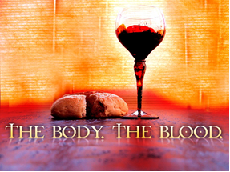
THE ORDINANCES

“For every time you eat this bread and drink this cup you are re-telling the message of the Lord’s death, that he died for you. Do this until he comes again.” 1 Corinthians 11:26 (LB)

- WHAT IS AN ORDINANCE?

- An ordinance is a decree or command by Jesus to his followers.

- New Era Church believes that Christ has commanded us to observe two ordinances: Baptism and The Lord’s Supper.

“Go ye therefore, and teach all nations, baptizing them in the name of the father, and of the Son, and of the Holy Ghost…” Matthew28:19a (KJV)

“…that on the night when Judas betrayed Him, the Lord Jesus took bread, and when he had given thanks to God for it, he broke it and gave it to his disciples and said, ‘Take this and eat it. This is my body, which is given for you. Do this in remembrance of me.’”
1 Corinthians11:23 (LB)

- These ordinances symbolize what Jesus did for our salvation, what Jesus does in the believer and faith in Jesus’ return and its meaning. Baptism and the Lord’s Supper are not sacraments. They do not confer or impart grace in and of themselves; they are outward symbols of what we believe.
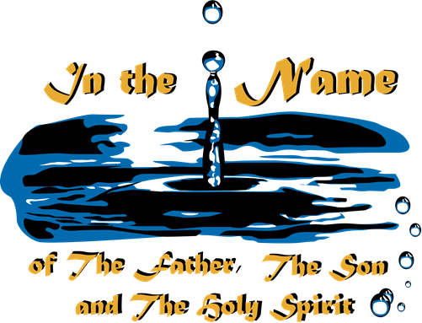

BAPTISM

A. Why Should I Be Baptized?

- To follow the example set by Jesus.

“At that time Jesus came from Nazareth and was baptized by John in the river.”
Mark 1:9 (GN)

- Because Jesus Christ commands it.
“Jesus said, ‘Go then, to all people everywhere and make them my disciples, baptize them in the name of the Father, the Son, and the Holy Spirit, and teach them to obey everything I have commanded you.’” Matthew 28:19-20 (GN)

- It demonstrates to others that I really am a believer.

“We know that we have come to know Him if we obey His commands.”
1 John 2:3 (NIV)

B. What Is The Meaning Of Baptism?

- Baptism illustrates Jesus’ death, burial and resurrection.

“Christ died for our sins…He was buried…and He rose again.” 1 Corinthians 15:3-4 (KJV)

- Baptism illustrates my new life as a Christian.

“For in baptism you see how your old, evil nature died with him and was buried with him; and then you came up out of death with him into new life…”
Colossians 2:12a (LB)

“By our Baptism then, we were buried with Him and shared His death, in order that, just as Christ was raised from the dead…so also we may live a new life.”
Romans 6:4 (GN)

- Baptism doesn’t make you a believer; it demonstrates that you already believe. It’s important to understand that baptism does not save you. You are saved only through your faith in Jesus.

“For it is by grace you have been saved through faith…it is the gift of God, not by works, so that no one can boast.” Ephesians 2:8-9 (NIV)

- Baptism is an outward sign of an inner commitment. Baptism is like a wedding ring, it’s the outward symbol of the commitment you make in your heart.

C. Why Be Baptized By Immersion

- Because Jesus was baptized that way.

“As soon as Jesus was baptized, he came up out of the water…”
Matthew 3:16a (GN)
- Every baptism in the Bible was by immersion.

(Example) “…then both Philip and the official went down into the water and Philip baptized him. When they came up out of the water…” Acts 8:38-39
- The word “baptize” means to dip under water.

The Greek word “baptize” means “to immerse or dip under water.”

- Immersion best symbolizes a burial and resurrection.

“When someone becomes a Christian, he becomes a brand new person inside. He is not the same any more. A new life has begun!” 2 Corinthians 5:17(LB)

D. Who Should Be Baptized?

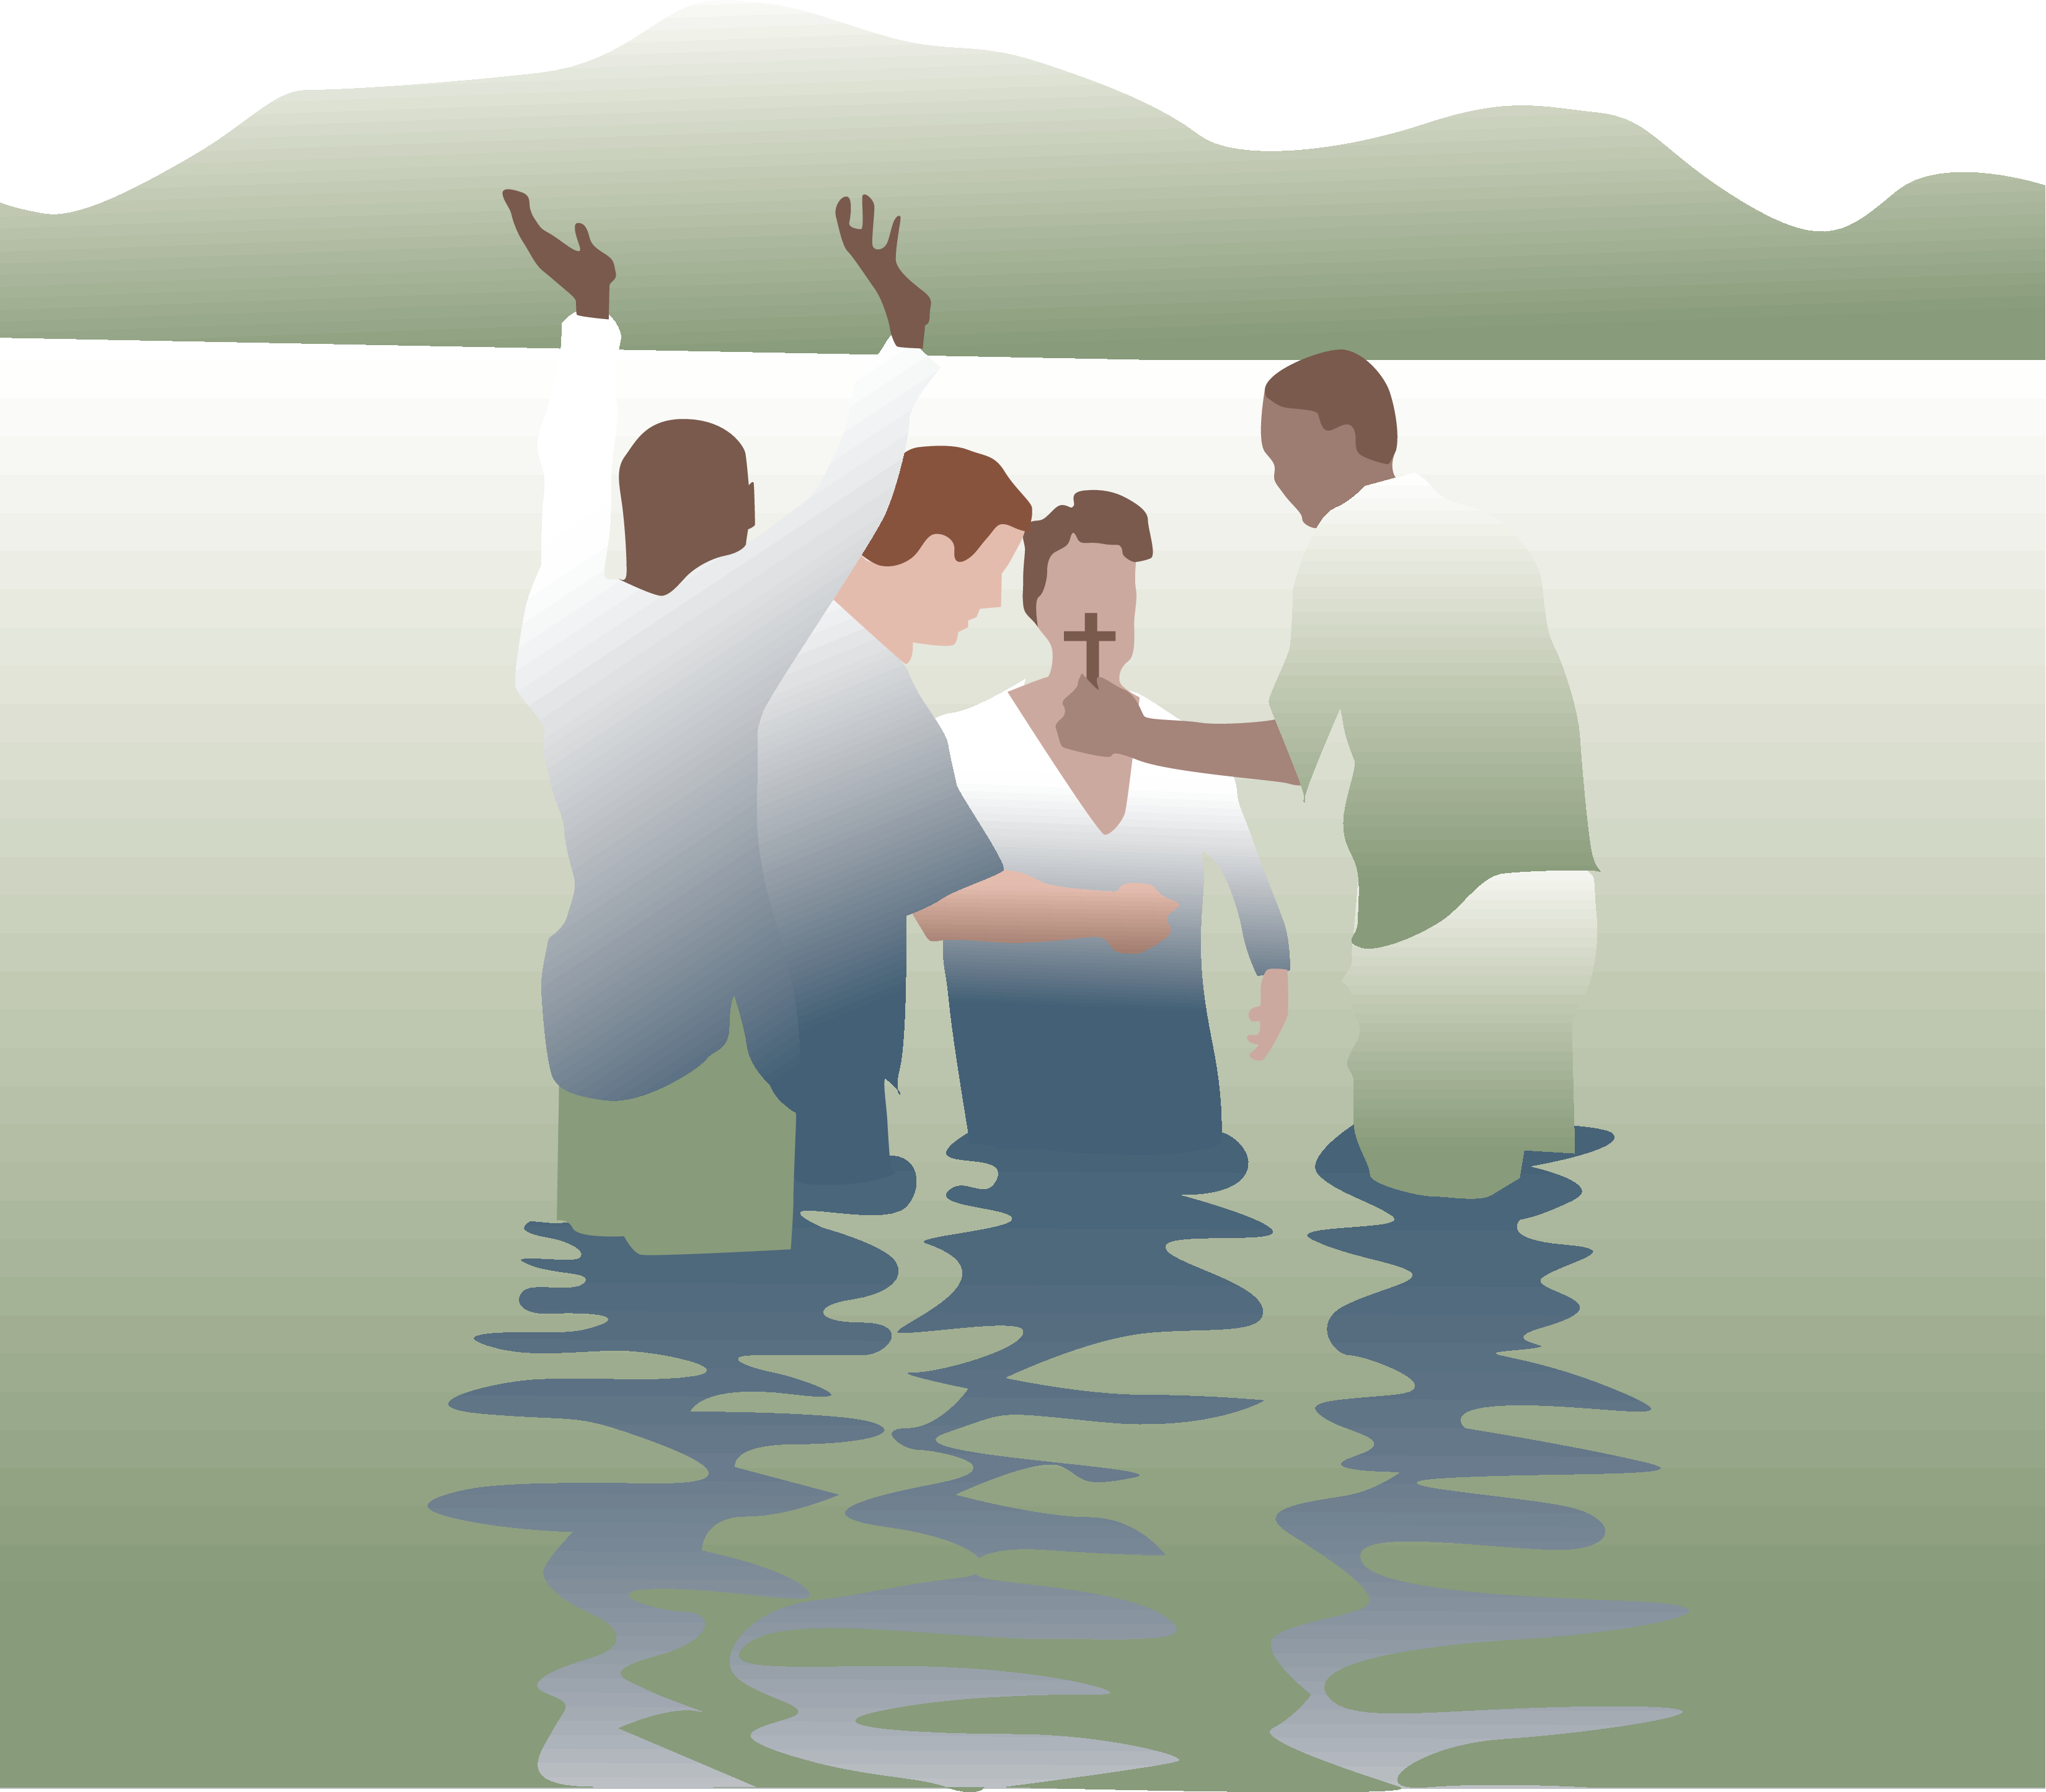
Every person who has believed in Christ should be baptized.

“Those who believed and accepted His message were baptized…” Acts 2:41

“Simon himself believed and was baptized…” Acts 8:13

“But when they believed Philip as he preached the good news…and the name of Jesus Christ, they were baptized, both men and women.” Acts 8:12

E. What If I Was Baptized As An Infant?

- Some churches baptize infants. At New Era we only baptize believers. In the Bible men and women were baptized following their belief in Jesus.

“Those who believed and accepted His message were baptized…” Acts 2:41

“Simon himself believed and was baptized…” Acts 8:13

“But when they believed Philip as he preached the good news…and the name of Jesus Christ, they were baptized, both men and women.” Acts 8:12

- The custom of infant baptism began about 300 years after the Bible was completed. It is a ceremony intended to emphasize a commitment between the parents and God on behalf of the child. During this ceremony, the parents promise to raise their child in the faith until the child is old enough to make his or her own personal confession of Christ.

- At New Era we have a Service of Dedication for infants and children which emphasizes the parent’s role in raising a child to follow Christ. Again, when it comes to baptism, we wait until children are old enough to believe in Jesus’ death and resurrection before we baptize them.

- Therefore, if you were baptized as an infant or were too young to remember the significance of your actions, we encourage you to talk with your Deacon Shepherding Team or the Pastor about getting rebaptized as a believer to publicly profess your personal commitment to Jesus Christ.

F. Is Baptism Necessary For Salvation?

- At New Era we believe that Baptism is symbolic, we submit to baptism because we are saved, not in order to be saved. Baptism is an outward symbol of an inward commitment. Therefore, if I am unable to be baptized (due to physical impairment) or if I die prior to being baptized, I am still saved. Baptism is not necessary for salvation, only faith in Jesus Christ.

“Then he said, ‘Jesus, remember me when you come into your Kingdom.’ And Jesus replied, ‘Today you will be with me in Paradise. This is a solemn promise.’”
Luke 23:41-42 (LB)

III. THE LORD’S SUPPER (1 Corinthians 11:23-26)

What Is The Lord’s Supper: Communion?

- It is a symbolic act, not a sacrament.
“The Lord Jesus, on the night He was betrayed, took bread…” 1 Corinthians 11:23b (NIV)

- It is a reminder.
“…and when he had given thanks, He broke it and said, ‘This is my body, which is given for you; do this in remembrance of me.’” 1 Corinthians 11:24 (NIV)

- It is a symbol.
“In the same way, after supper He took the cup, saying, ‘This cup is the new covenant in my blood; do this, whenever you drink it, in remembrance of me.’”
1 Corinthians 11:25 (NIV)

- It is a statement of faith.
“For whenever you eat this bread and drink this cup, you proclaim the Lord’s death until He comes.” 1 Corinthians 11:26 (NIV)

Who Should Take The Lord’s Supper?

Only those who are already believers should take the Lord’s Supper.

“For anyone who eats and drinks without recognizing the body of the Lord eats and drinks judgment on himself.” 1 Corinthians 11:29 (NIV)

How Do I Prepare Myself For The Lord’s Supper?

“Therefore, whoever eats the bread or drinks the cup of the Lord in an unworthy manner will be guilty of sinning against the body and blood of the Lord. A person ought to examine himself before he eats of the bread and drinks of the cup.”
1 Corinthians 11:27-28

Preparation for the Lord’s Supper is made by:

- Self-examination -
“Therefore, whoever eats the bread or drinks the cup of the Lord in an unworthy manner will be guilty of sinning against the body and blood of the Lord.”
1 Corinthians 11:27

- Confession of sins -
“If we confess our sins, he is faithful and just and will forgive us our sins and purify us from all unrighteousness.” 1 John 1:9

- Recommitment -
“Therefore, I urge you, brothers in the view of God’s mercy, to offer your bodies as living sacrifices, holy and pleasing to God, which is your spiritual worship.”
Romans 12:1 (NIV)
- Restoring relationships -
“Therefore, if you are offering your gift at the altar and there remember that your brother has something against you, leave your gift there in front of the altar. First go and be reconciled to your brother; then come and offer your gift.”
Matthew 5:23-24 (NIV)

When And How Often Should We Partake The Lord’s Supper?

Jesus never said when or how often believers should partake the Lord’s Supper. Instead, he said “…this do ye, as often as ye drink it, in remembrance of me.” 1 Corinthians 11:25b

Because we don’t want to take the Lord’s Supper so often that it becomes mundane and has no meaning and because we don’t want to take it so infrequently that we forget its sacredness, NNE observes the Lord’s Supper on the 1st Sunday of each month.

When we take the Supper we must always remember the great sacrifice Jesus made for us by giving his very life for us.

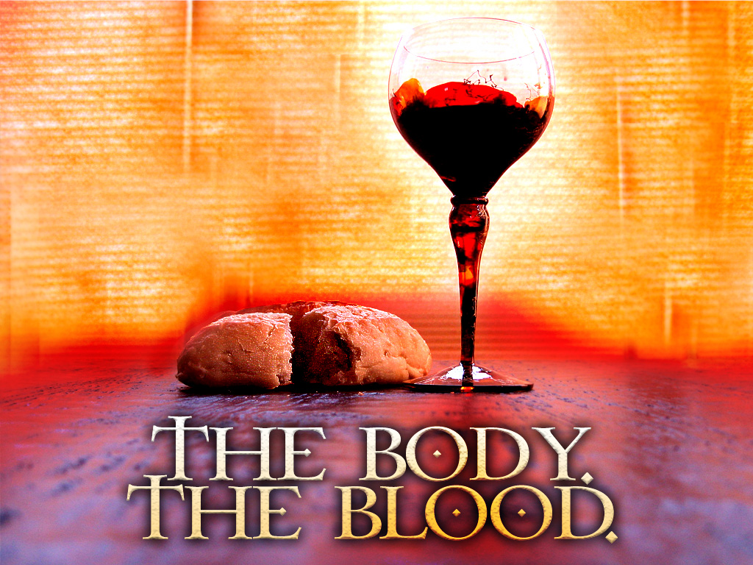

New Life Series

Module 2


THIS IS NEW ERA

“You are members of God’s very own family . . . and you belong in God’s household with every other Christian.”

Ephesians 2:19 (LB)

Welcome To New Era Baptist Church!

This lesson is designed to help you better understand the History, Vision, Mission, Practice and Structure of NNE. We are thrilled that you have decided to become a member of our church. In addition to providing you with this information, we hope to get to know you a little better and give you the opportunity to meet some of our leadership team.

How We’ve Grown (Our History)

The story of the beginning of Northside New Era Missionary Baptist Church dramatically shows what resulted when two great organized bodies of baptized believers combined their forces to form a more perfect union and become a more efficient channel through which God’s Word could be perpetuated.

The Northside Baptist Church was organized in the year 1934 under the guiding hand of Rev. Broadus A. Hogan. The church, which was located at the corner of 30th and Ethel Streets, made rapid growth numerically and spiritually. In the year 1942 the Rev. S. C. Richards accepted the call to the pastorate of the church.

The New Era Baptist Church was organized on March 16, 1939, in the home of Mr. and Mrs. Roscoe Morten, located at 816 Camp Street, with forty members present. The church was organized by Rev. Ira Hinden of Chicago, Illinois.

In a special meeting on March 24, 1941, the officers of the New Era Baptist Church called an Ordination Council for the purpose of ordaining Brother N. E. Vincent into the ministry. Rev. Vincent was elected Assistant Pastor of the New Era Baptist Church by unanimous vote on January 21, 1942.

In 1945 the Northside Baptist Church extended an invitation to the New Era Baptist Church to combine the two churches. The members of both organizations prayerfully considered the possibilities and felt that they could render more efficient service in the spreading of God’s Word.

On November 30, 1945, the New Era Baptist Church and the Northside Baptist Church were united into one body. The name became Northside New Era Missionary Baptist Church. Rev. Marshall A. Talley was elected pastor of the united body and Rev. N. E. Vincent was elected as assistant pastor. The first worship service of the Northside New Era Baptist Church was held in the Northside Baptist Church building on the second Sunday in December, 1945. This meeting was a glorious occasion.

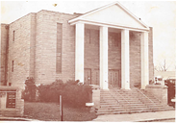
In the year 1950, Dr. Marshall A. Talley resigned from the pastorate and the Rev. N. E. Vincent was elected as his successor. Under the direction of Rev. Vincent, the plans for a new building were brought to full flower. The structure was to be built at a cost of approximately $90,000, not including the furnishing and furniture. While the building program was under way, the congregation held services in the basement portion of the building. On April 10, 1953, grateful and proud members of the Northside New Era Missionary Baptist Church, marched into this beautiful edifice.

Rev. Robert L. Coleman of Owensboro, KY., served as Pastor of Northside New Era Missionary Baptist Church from October 22, 1978 until October 16, 1988.

The spiritual leadership became the responsibility of the Board of Deacons in October, 1988, under the direction of the Chairman, Deacon Robert Littlejohn. He was ably assisted and supported by the ministry of Rev. Clyde Woods and the Deacons. The Board of Deacons along with the Pastor Search Committee, regularly supplied our pulpit with visiting Ministers.

Rev. Clarence C. Moore, of Second Baptist Church, Kokomo, Indiana, was called to the Pastorate of Northside New Era Missionary Baptist Church. He preached his first sermon on August 29, 1990 as our Pastor and was installed on October 23, 1990. Rev. Moore and his family have brought to us, more love, more strength and more faith in the great God, who has so far sustained us. His love for the sinner, as well as the saved is freely given. His joy in spreading the gospel of our Savior Jesus Christ is contagious. It spreads from heart to heart.

Northside New Era Missionary Baptist Church has seen tremendous growth during his tenure. Spiritually, materially and financially, we have truly been blessed. Our church has grown with over 400 new members being added to our church family. A new church van and four properties were purchased by the church to further our Christian endeavors.

Rev. Dr. Clarence C. Moore was born November 28, 1955 in Winston-Salem, North Carolina to Clarence and Lee Hilda Hooks Moore. He is the eldest of five children. He attended the public schools of Winston-Salem. Upon graduation, he enrolled at the University of North Carolina at Greensboro where he received a Bachelor of Science in Business Administration in May 1978. While at the University, Rev. Moore received various awards and recognition. He was voted Outstanding Senior by the graduating class of 1978 and was chosen by the Chancellor of the University to serve on the Honor Code Committee and advisory Council. Rev. Moore accepted Jesus as his personal Savior at an early age and was baptized in the Canaan Missionary Baptist Church, Winston-Salem, North Carolina.
In September 1978, Rev. Moore went to Kokomo, Indiana to work as a Purchasing Expeditor for Delco Electronics. While in Kokomo he joined the Second Missionary Baptist Church. In 1982, he was ordained a deacon of the Second Missionary Baptist Church. On January 15, 1984, the Second Missionary Baptist Church licensed Rev. Moore into the Gospel Ministry. In September 1984, he enrolled in Central Baptist Theological seminary and graduated in May 1990, with a Bachelor of Theology degree. On October 22, 1988, Rev. Moore was ordained into the Gospel Ministry by the Second Missionary Baptist Church.
On April 24, 1990, Rev. Clarence C. Moore, of Second Baptist Church, Kokomo, Indiana, was called to the Pastorate of Northside New Era Missionary Baptist Church. He preached his first sermon on August 29, 1990 as our Pastor and was installed on October 23, 1990.
During Pastor Moore’s tenure the Northside New Era Baptist Church has seen tremendous growth. On June 30, 1996, the Northside New Era Church family held a ribbon-cutting service for the completion of Phase II of our rebuilding program. During this historic celebration, we dedicated, to the glory of God, our new elevator addition, a complete renovation of our beautiful worship center.
Since Pastor Moore’s tenure we have purchased over 30 new properties, including the old Bosma property across the street for future expansion. In April of 2007 the church broke ground for our new (22,000 sq. ft.) Education and Administration center with over 19 classrooms, new offices, Youth and children rooms, Daycare nursery, coffee shop and flexible ministry spaces. With a membership approaching 1,800 we continue to grow. God has truly blessed our efforts. We dedicated our new facility “Sanctuary II” on October 12, 2008.
On August 21, 2010 at his 20th Pastoral Appreciation Gala and Banquet, Pastor Moore was presented with an Honorary Doctorate of Divinity from Saint Thomas Christian College of Jacksonville, FL. May God continue to bless Dr. Moore with many more years to come. To God be the Glory!
Where We Are Going (Our Future)

As we embark upon this next phase of development for New Era Church, we expect to move closer to our Church Vision, which states “New Era Church is a faith community which provides a holistic approach to ministry by meeting the spiritual, emotional, physical, and intellectual needs of all God’s people”.

- Strategic Plan

We envision that New Era will over the next 10 years:
  - Be a church that has a Biblical world view
  - Be comprised of members who hunger and thirst for the Word of God and spiritual growth and development in every area of their lives
  - Be comprised of members who will see serving in a ministry and volunteering in the community as a priority
  - Be the church that the un-churched wants to attend
  - Be a church that appeals to and meets the needs of the congregation, including young adults between the ages of 18 – 35, and diverse cultures, through communication, activities and resources
  - Be comprised of members who understand and support Mission trips
  - Be a church where members bring their tithes, offerings, and leave a financial legacy
  - Be a church that communicates via every available communication tool
  - Be a church that partners with municipal leaders and has a voice in the direction and development of the community
  - Be a church that
    - Houses a new worship center with a 1,200 – 1,500 seat sanctuary
    - Reaches weekly attendance of 5,000 in worship services (Sunday Worship, Children and Youth services and programs, Bible Study, Elevate, Enrichment Hour, Small Groups, etc)
    - Brings the Community Center back to the church by providing:
      - Senior Center/Senior Daycare
      - Senior Housing
      - Family Life Center (gym, daycare, youth activities, etc.)
      - Resources Center (inclusive of a computer lab)
    - Is adequately staffed to support the growth and development of the Ministry and the services it will provide.
  - Have a New Era – West location that appeals to and is convenient for families that live in the Avon, Plainfield, and Brownsburg areas.

What We Practice

(OUR LIFESTYLE STATEMENT)

Beliefs are not worth much unless they are translated into actions. Based on what the Bible teaches, we feel very strongly about the following seven practices:

- BIBLE AS OUR SOLE AUTHORITY
Since God’s Word is the only completely reliable and truthful authority, we accept the Bible as our manual for living. Our first question when faced with a decision is “What does the Bible say?” We practice daily Bible reading, Bible study, and Bible memorization. The Bible is the basis for all we believe.
“The whole Bible was given to us by inspiration from God and is useful to teach us what is true and make us realize what is wrong in our lives; it straightens us out and helps us to do what is right.” 2 Tim. 3:15 (LB)

- AUTONOMY OF EACH LOCAL CHURCH
Christ is the recognized head of our church, not any person, group, or religious organization. While recognizing the value of associating or cooperating with other groups of Christians, we believe every local church should be self-governing and independent from any denominational control.
“Christ is the head of his Body, the church. He is the source of the Body’s life…”
Col. 1:18 (GN)
- MINISTRY OF EVERY BELIEVER
The Bible teaches that every Christian is called to “full time” Christian service, regardless of his or her vocation. We practice the truth that every believer is a minister by encouraging every member to find a place of service and ministry. Every believer has direct access to God through prayer and Bible reading.

“You are…the King’s priests…God’s own people, chosen to proclaim the wonderful acts of God.” 1 Peter 2:9 (GN)

- TITHING
At New Era we practice tithing for the support of Christ’s Body, the church, as God commands. We recognize that giving 10% of our income is the Biblical standard of giving.

“A tithe of everything you produce belongs to the Lord; it is holy to the Lord.” Lev. 27:30

- IMMERSION
We practice baptism by immersion because Jesus was baptized that way and immersion best symbolizes a death, burial and resurrection.

“For when you were baptized, you were buried with Christ, and in baptism you were also raised with Christ…” Col. 2:12 (NIV)

- SPIRIT-LED LIVING
We believe the only way possible to live the Christian life is by God’s power within us. We seek to practice a daily dependence of God’s Spirit to enable us to do what is right.
Phil. 2:13; Eph. 5:18

“Christ loves us, and by his death he has freed us from our sins and made us a kingdom of priests to serve God…” Rev. 1:6 (GN)

- TELLING OTHERS ABOUT CHRIST
It is the responsibility of every Christian to share the Good News with those God brings us into contact with. We practice personal sharing about Christ and inviting friends to church.
“Therefore, go and make disciples in all the nations, baptizing them in the name of the Father, of the Son and of the Holy Spirit, and teaching them to obey everything I have commanded you.” Matt. 28:19-20 (NIV)

What We’re About…

Our Vision

New Era Church is a faith community which provides a wholistic approach to ministry by meeting the spiritual, emotional, physical, and intellectual needs of all GOD’s people.


“Let there be real harmony among you so there won’t be any split in the church. I plead with you to be of one mind, united in thought and purpose.”
1 Corinthians 1:10 (LB)

“God gave some to be pastors and teachers, to prepare God’s people for works of service, so that the body of Christ may be built up.” Ephesians 4:11-12

Our Mission
We live in a lost and dying world which continues to pursue its failing strategies for meaning and fulfillment in life. While people often look good on the outside, their lives are sometimes more accurately characterized by self-indulgence, guilt, lust, confusion and despair. Seeking his own remedies, man continues his downward spiral of separation from God. Man's only hope is the person of Jesus Christ. For men to turn to Christ, they must be told about Him and to see His reality displayed in the lives of His followers. As the body of Christ, the church is the visible earthly representation of who He is. Every church has the two-fold purpose of leading people to Christ and maturing them in the faith.

Our expression of this purpose is the following:
New Era Church exists to:

- Evangelize the lost
- Edify the saved
- Minister to those in need
- Be a Conscious in the community
Then Jesus came to them and said, “All authority in heaven and on earth has been given to me. Therefore go and make disciples of all nations, baptizing them in the name of the Father and of the Son and of the Holy Spirit, and teaching them to obey everything I have commanded you. And surely I am with you always, to the very end of the age.” Matthew 28:18-20 (NIV)

Why We Exist…

New Era Church Exists To:

Celebrate God’s presence through worship.

WORSHIP: Establishing A Personal Experience With God

“Worship the Lord your God, and serve him only.” Matt 4:10

Our Worship Style

Our style at NNE is designed to facilitate the opportunity for the worshipper to encounter Christ. We pride ourselves in creating a spontaneous and spirit-led worship environment. We offer two services on Sundays, 9:00 a.m. & 11:30 a.m. Our services offer examples of:

- “Celebration”

“I rejoiced with those who said to me, “Let us go to the house of the Lord.” Psalm 122:1

- “Inspiration”

“…but those who hope in the Lord will renew their strength. They will soar on wings like eagles; they will run and not grow weary, they will walk and not be faint.” Isa. 40:31

- “Preparation”

“It was he who gave some to be apostles, some to be prophets, some to be evangelists, and some to be pastors and teachers, to prepare God’s people for works of service, so that the body of

Christ may be built up…” Eph. 4:11-12

Communicate God’s word through evangelism.

EVANGELISM: Sharing the Good News

“Therefore go and make disciples of all nations, baptizing them in the name of the Father and of the Son and of the Holy Spirit, and teaching them to obey everything I have commanded you. And surely I am with you always, to the very end of the age.”
Matt. 28:18-20

Why Our Church and Ministry Must Never Stop Growing:

- Because God Loves People:

“The Lord…is patient, not wanting anyone to perish, but wants everyone to come to repentance.” 2 Peter 3:9 (also see 2 Cor. 5:14; Luke 15:3-10; Matt. 9:12-13)

- Because Jesus Commanded Us To Tell Everyone About Him:

“Go out into the country…and urge anyone you find to come in, so that My house will be full.” Luke 14:23

- Because Growth Is God’s Will:

“Under Christ’s control, the whole Body is nourished…and grows and God wants it to grow.” Col. 2:19 (GN)

Unbiblical Excuses for Not Growing

- “God isn’t interested in numbers”
- “Our church wants quality not quantity”
- “Large churches are impersonal”
- “We like our group small”

We believe our church must grow numerically and spiritually at the same time.
“And the Good News of the Kingdom will be preached to the whole world as a testimony to all nations, and then the end will come.” Matthew 24:14

Educate God’s people through discipleship.

DISCIPLESHIP: Growing Spiritually
“Let us leave the elementary teaching about Christ and go on to maturity…”
Hebrew 6:1

We exist to demonstrate God’s love through ministry.

MINISTRY: Meeting the Needs of People:
“By this shall all men know that you are my disciples, that you have love for one another.” John 13:35

SMALL GROUPS
- The “heartbeat” of caring relationships at NNE is Small Groups, Sunday School, and our Deacon Shepherding Ministry. Every member needs to be a part of one. Small groups offer a place to experience the care and love of the church family while learning together. These groups offer a unique place for every member to minister and to be ministered to.

Incorporate God’s plan through stewardship.

STEWARDSHIP: Supporting the Ministry by using God’s Plan or Doing it God’s Way

- Stewardship involves our Time, our Talent (gifts) and our Tithe.

“Bring me the whole tithe into my storehouse. Test me in this,” says the Lord, “and see if I will not throw open the flood gates of heaven and pour out so much blessing that you won’t have room enough for it! I will prevent pests from devouring your crops and the vines in your fields will be protected from plagues.” Mal. 3:10-11

Membership at New Era Church

One may become a member at New Era Church by:

Candidate for Baptism

Receive Jesus Christ as Lord and Savior by:
  - Admitting you are a sinner Romans 3:23

  - Acknowledging that Jesus Christ is God’s only Son, that he paid the penalty for your sin by His death on the cross, and that He made it possible for a new style of life through His resurrection. Romans 10:9; 6:23

  - Totally trusting Jesus Christ by:

    - Accepting His free forgiveness
    - Repenting of past wrongs
    - Being baptized by immersion into Him and
    - Surrendering your abilities, your desires, your whole life to Him Acts 2:38; Rom. 6

Letter

Upon presentation of a letter of dismissal and recommendation from some other Baptist church

Christian Experience

Anyone who has no letter, but has professed a faith in Jesus Christ as their personal savior and has been baptized through water immersion

Reinstatement

Any person who has been inactive and out of fellowship, and has not joined another congregation may seek restoration of full membership by reinstatement

Watch Care

This person is not seeking full membership (no voting rights) to New Era but for a specific period of time is asking that our Church family extend a hand of fellowship and nurture while they are in our midst.

Expectations of Membership

There's more to being a Christian than having your name on a church roster. As with any organization you join, there are certain expectations of membership. At New Era Church, our members have united and have invested themselves in the ministry of the church through prayer, relationships, service, and through the investment of their personal time, treasures and talents. New Era members are encouraged to give of their:

1. Talents (Gifts) - Use your God-given gifts for His glory

2. Time - Devote at least one hour a week to each of the following:
Worship (attend church weekly)
Sunday School or Bible Study
Fellowship - get in some kind of small group
Serving - find your place of contribution

3. Tithe - Return a portion of God's material blessings to Him / Tithe means a tenth

Your Responsibilities to New Era:

- To desire to grow spiritually

- To love and share in your Church’s mission (Worship, Evangelism, Discipleship Ministry and Stewardship)

- To be Christ like at all times

New Era’s Responsibilities to You:

- To help you understand the conversion experience
- To help you mature in your spiritual walk, through our worship experiences, bible study, prayer services, Sunday School, small groups and etc.

- To care for, comfort and support you in times of distress and need

- To help you reach your God given potential and purpose.
Etiquette at New Era:

In order to keep our services orderly and maintain the proper worship atmosphere for everyone, we ask that you observe the following:
- Please do not walk during-
1) The reading of Scripture
2) The invitation to Christian Discipleship (Making a decision to accept Jesus)
3) The Sermon

- Please do not eat or drink in the sanctuary

- If your baby begins to cry excessively, we ask that you take him/her to the foyer to comfort them.

The New Era Membership Covenant

Having received Jesus as my Lord and Savior, and being in agreement with the church’s statements, strategies, and structure, I covenant myself with the New Era Church Family. In so doing, I commit myself to God, to the church’s leadership, and to other members who are a part of this fellowship to do the following:

- I will protect the unity of my church:
“So let us concentrate on the things which make for harmony, and on the growth of our fellowship together.” Rom. 14:19 (Phillips)

- I will share the responsibility for my church:
“So warmly welcome each other into the church, just as Christ has warmly welcomed you; then God will be glorified.” Romans 15:7 (LB)

- I will serve the ministry of my church:
“There are different kinds of service to God…together you form the body of Christ and each of you are a necessary part of it.” 1 Cor. 12:5-7 (LB)

- I will support the testimony of my church
“You are members of God’s very own family…and you belong in God’s household with every other Christian.” Eph. 2:19 (LB)

- I will support the Vision and Mission of my church:
“Always be prepared to give an answer to everyone who asks you to give the reason for the hope that you have. But do it with gentleness and respect.” 1 Peter3:15

New Era Church
Pastor Clarence C. Moore, Senior Pastor

A Kingdom Culture for Ministry

Definition: The Kingdom Agenda is defined as the visible demonstration of the comprehensive rule of God over every area of life. This rule is reflected through the four divinely ordained spheres of the individual, the family, the church and the government.

The Spirit of the Ministry

I. The Spirit of Unity: To work in harmony toward a shared purpose and vision.

Make every effort to keep the unity of the Spirit through the bond of peace. Ephesians 4:3

II. The Spirit of Integrity: To possess a commitment to biblical truth and honesty, refusing to allow our character to be corrupted or compromised.

May integrity and uprightness protect me because my hope is in you; Psalms 25:21

III. The Spirit of Excellence: To work as unto the Lord with the highest degree of professionalism, productivity and skill.

…And every willing man skilled in any craft will help you in all the work. 1 Chronicles 28:21

IV. The Spirit of Servanthood: To demonstrate true humility by seeking, serving and protecting the wellbeing of others.

Each one should use whatever gift he has received to serve others, faithfully administering God’s grace in its various forms. 1 Peter 4:10

V. The Spirit of Communication: To interact with each other on matters of the ministry in a respectful and timely fashion.

Do not let any unwholesome talk come out of your mouths, but only what is helpful for building others up according to their needs, that it may benefit those who listen. Ephesians 4:29

VI. The Spirit of Accountability: To love, encourage and correct each other as we do the work of the ministry, each taking responsibility for decisions and actions that impact the ministry.

So in Christ we who are many form one body and each member belongs to all the others.
Romans 12:5

VII. The Spirit of Joy: To have a positive, infectious, and cheerful attitude while performing assigned tasks and responsibilities.

Rejoice in the Lord always. I will say it again: Rejoice!
Philippians 4:4

